**CS 340 README Project 2**

**About the Project/Project Title**

The purpose of this dashboard is to allow a user to access Austin Animal Shelter’s database of animals. The user can see a dashboard containing different animals as well as their rec_num, age_upon_outcome, animal_type, breed, etc. as can be seen in this screenshot:

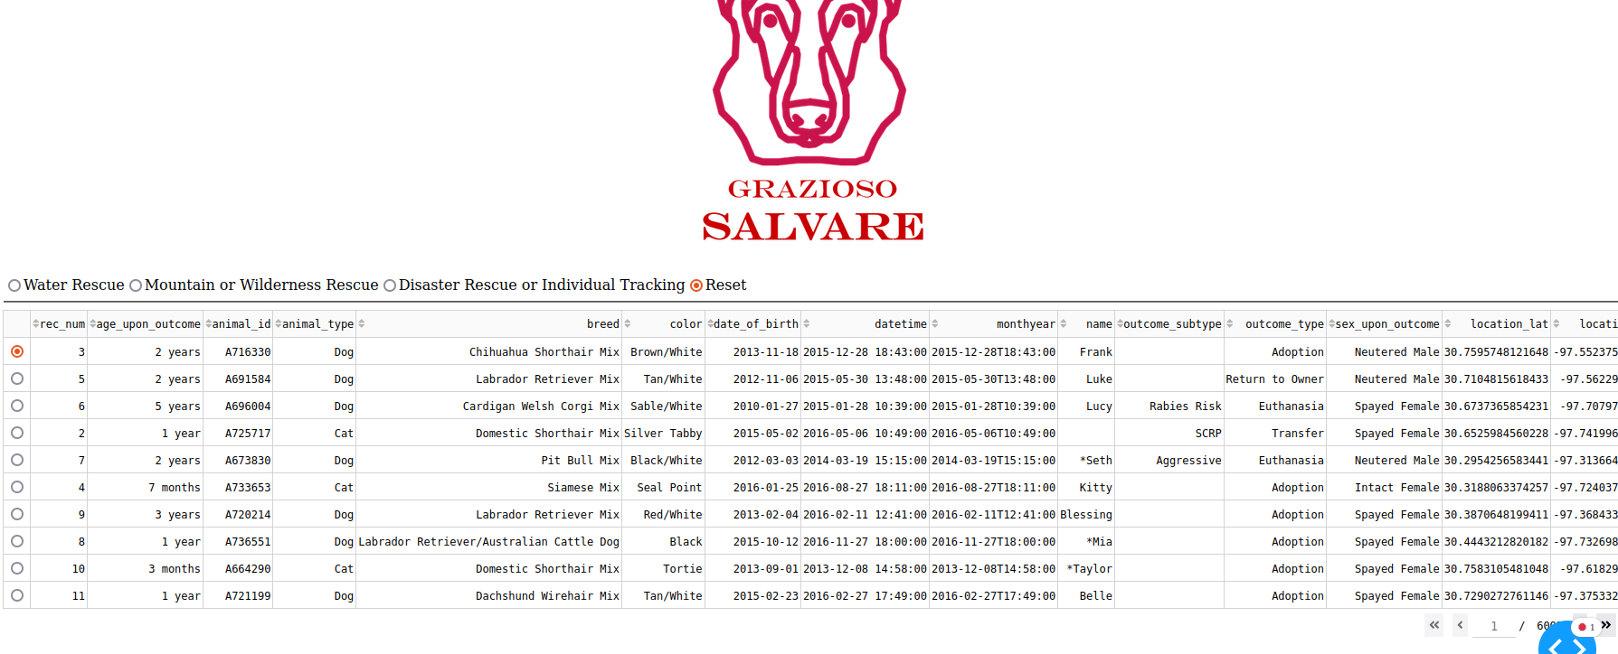

The user can also select the radio buttons above the list and filter the animals shown based on their rescue type (water, mountain/wilderness, and disaster/individual tracking) and can also be reset to no filter, which is what it starts off as:

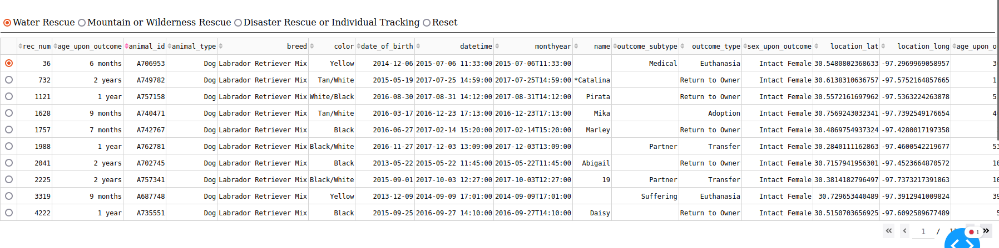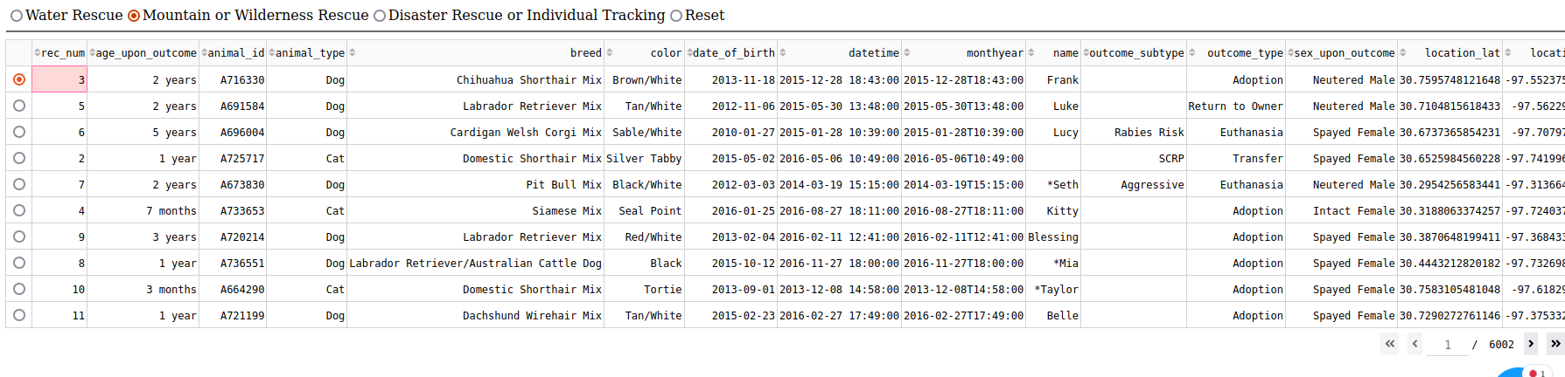

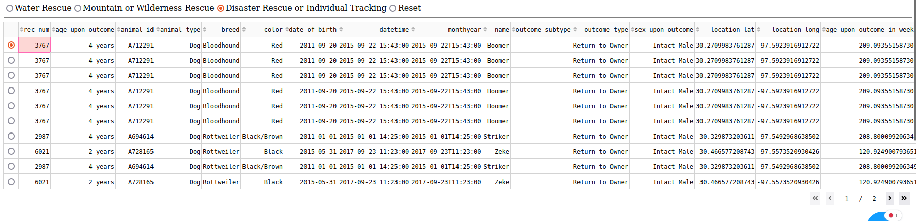

Finally, there is a histogram chart that shows a comparison of breeds, as well as a map to show the location of the selected animal. If no animal has been selected, the first animal on the page is selected by default:

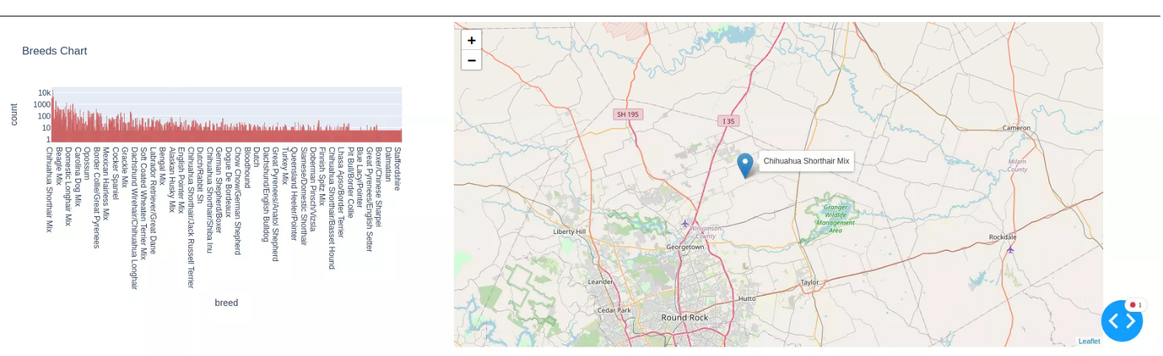

**Motivation**

This project was created to ease the use of the database, as well as strengthen my skills when it comes to working with databases. User access to the database can be possible with this project. Filtering animal rescue types, looking at a comparison of breeds, and seeing where the animals are on the map all make an interactive environment for the user.

**Getting Started**

To use this project follow these steps:

1. Import the CSV file using MongoDB:

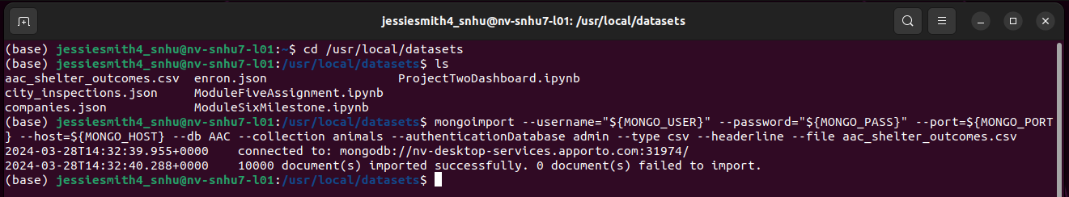

1. Create an index:

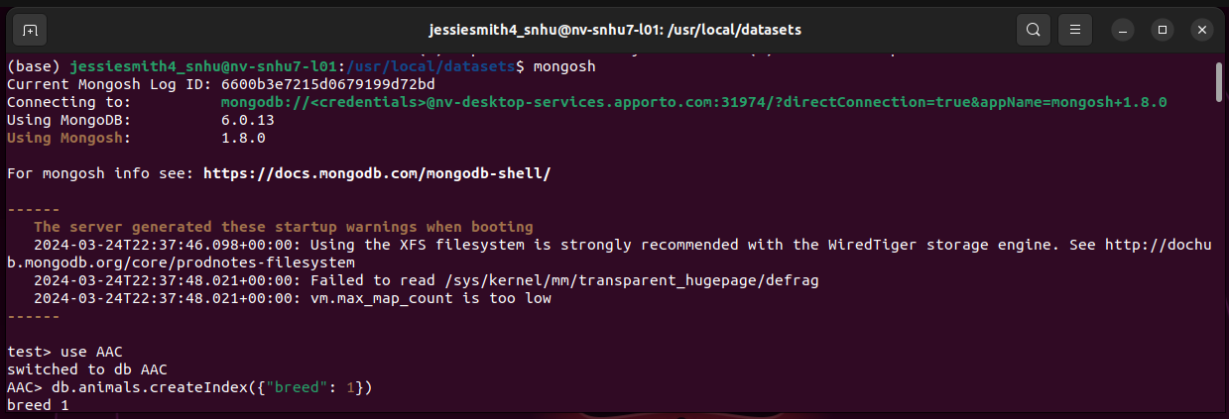

1. Create a user account with your own specified username and password:

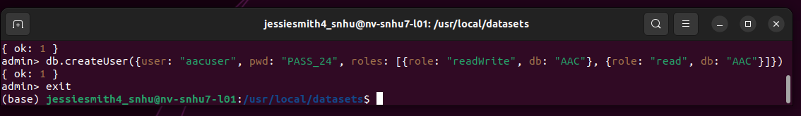

1. Ensure that the animalShelter.py and ProjectTwoDashboard.ipynb files are saved in the same location, and install JupyterNotebooks.
2. The listed username and password in the ProjectTwoDashboard.ipynb file would need to be changed to your own:

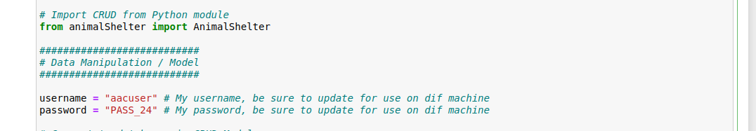

1. Now you can run the dashboard! It takes some time to load, so be sure not to get worried when it does not load immediately.

**Installation**

Python and JupyterNotebook is needed to run this project. MongoDB allows access to the database. dash_leaflet, dash, plotly, base64, numpy, pandas, and matplotlib are needed in order to properly show the data on the graph and map.

Links:

<https://jupyter.org/install>

<https://www.mongodb.com/docs/manual/installation/>

**Steps**

To complete this project, I first began with uploaded the AAC csv file to MongoDB, then I created a user account as well as a user account. The animalShelter.py file was created to implement CRUD functionality, create, read, update, and delete. This allowed me to manipulate the data. Next I began working on the dashboard. The Grazioso Salvare image was placed at the top, with an anchor tag to <https://www.snhu.edu> was added, the list was created with radio buttons to filter, the map was added ad the bottom, and finally the histogram was created.

**Challenges**

My main challenge was getting the map to work as I changed the update_map function, the fix was as simple as changing the function back to the given function. I also struggled to get the filters to work, but that was because I had sort_mode set to single instead of multi.

**Contact**

Jessie Smith

jessie.smith4@snhu.edu